**WebDriver Entire Setup and Installation with Eclipse**

we would be discussing about the **installation procedure to get started with WebDriver initiating from the scratch**. We would also be discussing about the diverse range of drivers provided by WebDriver, each catering to different testing and environmental needs.

To be able to use WebDriver for scripting, there are some pre-requisites that need to be in place like the basic environment setup. In this series, we would be using Java as a programming language within our sample examples. Thus let us kick start with the Java installation.

### ****Java Installation****

**Step 1:** Go to Oracle official site – “[JAVA download](http://www.oracle.com/technetwork/java/javase/downloads/index.html)”, download Java Platform, Standard Edition. All the recent releases are available on the page.

[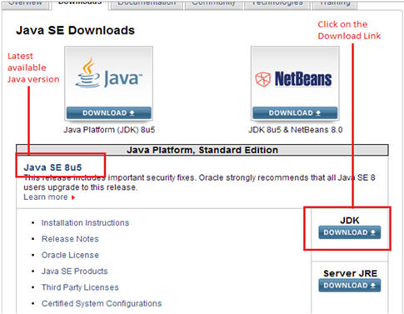](http://cdn.softwaretestinghelp.com/wp-content/qa/uploads/2014/10/webdriver-installtion-with-eclipse-1.jpg)

**Step 2:** As soon as you click on the Download button, following screen would appear. Accept the License agreement for Java installation and choose amongst the various catalogued Java Development Kit’s. Select the one that best suits your system configuration.

[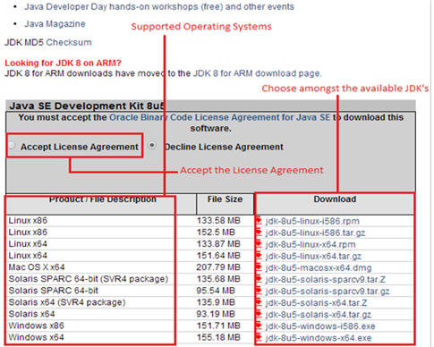](http://cdn.softwaretestinghelp.com/wp-content/qa/uploads/2014/10/webdriver-installtion-with-eclipse-2.jpg)

Remember to download JDK (Java development kit). The kit comes with a JRE (Java Runtime environment). Thus the user isn’t required to download and install the JRE separately.

### ****Eclipse IDE Installation****

**Step 1:** Go to Eclipse official website and navigate to its download page – [Eclipse download](http://www.eclipse.org/downloads/). Download Eclipse IDE for Java EE developers. All the recent releases are available on the page.

Make sure you opt and download the appropriate eclipse IDE as per your system configuration. There are two download links available for 64 bit windows operating system and 32-bit windows operating system.

[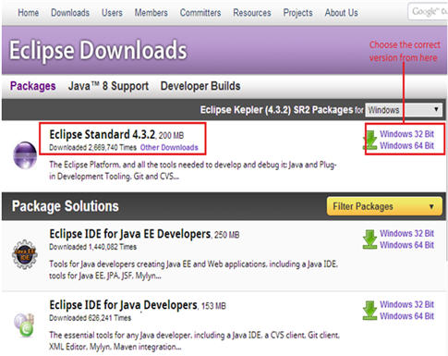](http://cdn2.softwaretestinghelp.com/wp-content/qa/uploads/2014/10/webdriver-installtion-with-eclipse-3.jpg)

**Step 2:** As soon as we click on the download link, the user is re-directed to the fresh page securing information about the current download. Click on the download icon and you are done.

[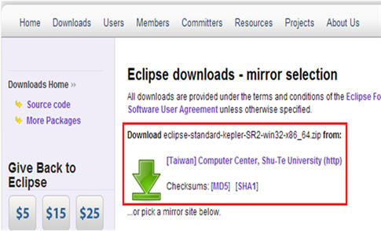](http://cdn2.softwaretestinghelp.com/wp-content/qa/uploads/2014/10/webdriver-installtion-with-eclipse-4.jpg)

It may take a few minutes before you can download the complete zip folder.

**Step 3:** Once downloaded, copy the folder and place it in the desired location on your file system.

[webdriver installtion with eclipse 5](http://cdn.softwaretestinghelp.com/wp-content/qa/uploads/2014/10/webdriver-installtion-with-eclipse-5.jpg)

**Step 4:** Extract the zipped folder, a folder named as eclipse can be seen. The folder embodies all the required application and source files.

[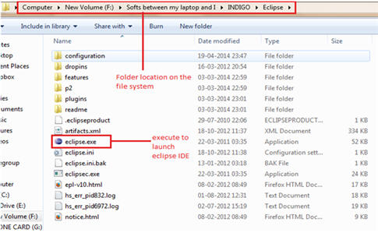](http://cdn.softwaretestinghelp.com/wp-content/qa/uploads/2014/10/webdriver-installtion-with-eclipse-6.jpg)

**Step 5:** Launch the eclipse IDE using “eclipse.exe” residing inside the eclipse folder. Refer the above illustration for the same.

**Step 6:** The application will prompt you to specify the workspace location. Workspace is that location where all your eclipse projects will be residing. Enter/Browse the desired location or the user can simply opt for the default location and click on the OK button.

[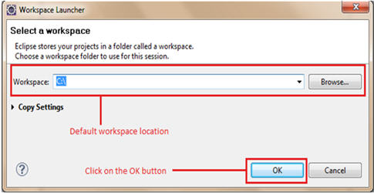](http://cdn2.softwaretestinghelp.com/wp-content/qa/uploads/2014/10/webdriver-installtion-with-eclipse-7.jpg)

### ****Configuring WebDriver****

As we would be using Java as the programming language for this series and in order to create test scripts in java, we would have to introduce language- specific client drivers. Thus, let us begin with the downloading of Selenium Java Client Libraries.

**Download the Selenium Java Client Libraries**

**Step 1:** Go to Selenium’s official website and navigate to its download page – “<http://docs.seleniumhq.org/download/>”. Refer the section in the below illustration where you can find Client Libraries listed for distinct programming languages. Click on the download link for Java Client Library.

[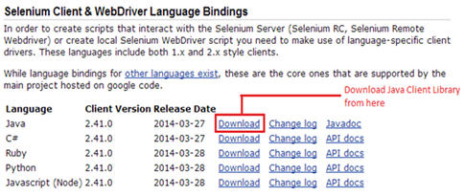](http://cdn.softwaretestinghelp.com/wp-content/qa/uploads/2014/10/webdriver-installtion-with-eclipse-8.jpg)

------------

It may take a few minutes before you can download the complete zipped folder.

**Step 2:** Once downloaded, copy the folder and place it in the desired location on your file system.

**Step 3:** Extract the zipped folder, a folder named as “Selenium-2.41.0.zip“can be seen. The folder embodies all the required jar files which enable users to create test scripts in Java.

Thus these libraries can be configured in Eclipse IDE.

**Configuring Libraries with Eclipse IDE**

**Step 1:** Navigate towards Eclipse IDE. Create a new java based project following File -> New -> Java Project. Refer the following figure for the same.

[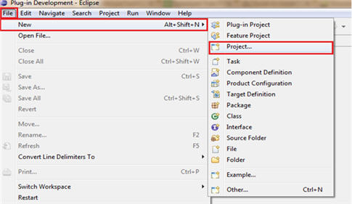](http://cdn.softwaretestinghelp.com/wp-content/qa/uploads/2014/10/webdriver-installtion-with-eclipse-9.jpg)

**Step 2:** Provide a user defined name for your Java Project. Let us provide the name as Learning_Selenium and Click on the Finish Button. The newly created project can be viewed at the left side of the screen in the package explorer panel.

**Step 3:** Create a new Java class named as “First_WebdriverClass” under the source folder by right clicking on it and navigating to New -> class.

**Step 4:** Now let us configure the libraries into our Java project. For this, select the project and Right click on it. Select “Properties” within the listed options. The following screen appears, Select “Java Build Path” from the options.

[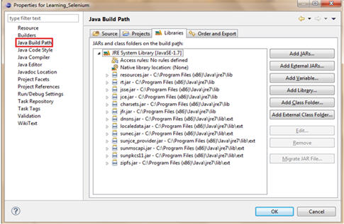](http://cdn2.softwaretestinghelp.com/wp-content/qa/uploads/2014/10/webdriver-installtion-with-eclipse-10.jpg)

**Step 5:** By default, “Libraries” tab is opened. If not, click on the “Libraries” tab. Then, click on the “Add External Jars…” button. Browse to the location where we have saved the extracted folder for Java Client Libraries.

**Step 6:** Select all the JAR files present in the “selenium-java-2.41.0” folder and click on open button within the dialog box. The properties dialog box should look like the below illustration.

[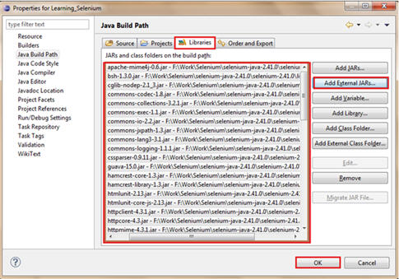](http://cdn2.softwaretestinghelp.com/wp-content/qa/uploads/2014/10/webdriver-installtion-with-eclipse-111.jpg)

**Step 7:** Click on the “OK” button within the dialog box so as to complete the configuration part of Selenium Libraries in our java project.

The project will look like the following:

[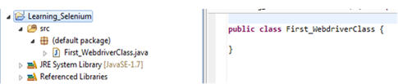](http://cdn.softwaretestinghelp.com/wp-content/qa/uploads/2014/10/webdriver-installtion-with-eclipse-12.jpg)

### ****Available Drivers****

There are a number of driver classes available in WebDriver, each catering a specific web browser. Each browser has a different driver implementation in WebDriver.

In WebDriver, a few of the browsers can be automated directly where as some of the web browsers require an external entity to be able to automate and execute the test script. This external entity is known as Driver Server. Thus, user is required to download the Driver Server for different web browsers.

Notice that there is a separate Driver Server for each of the web browser and user cannot use one Driver Server for web browsers other than the one it is designated for.

Below is the list of available web browsers and their corresponding Server Drivers.

[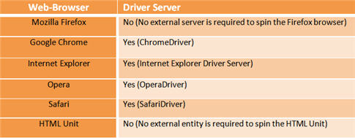](http://cdn.softwaretestinghelp.com/wp-content/qa/uploads/2014/10/webdriver-installtion-with-eclipse-13.jpg)

### ****Conclusion****

In this tutorial, we accustomed you with all the environment setup and installation to be done prior to creation of WebDriver test scripts.

Here are the cruxes of this article.

* Prior to the creation of WebDriver based test scripts, few utilities and packages are required to be installed.
* Install JDK (Java Development Kit). Remember, the user is not supposed to install JRE separately because it is distributed bundled with the kit.
* Download Eclipse IDE. User is only required to download the package and he/she is good to go. No other installation is required with Eclipse.
* Download Java Client Libraries to be able to create test script in java programming language.
* Launch eclipse using eclipse.exe. Select the workspace where you would want to save the projects.
* Create a new java project in the eclipse. Create a new java class within the project.
* Configure the eclipse by importing jars files for Java Client Drivers.
* In WebDriver, a few of the browsers can be automated directly where as some of the web browsers require an external Driver Server.
* Firefox and HTML Unit are the only browsers that cannot be automated directly. Thus they do not require any separate Driver Server. All other commonly known web browsers like Chrome, Safari, Internet Explorer etc. requires Driver Servers.